- Mechanism Failure and degradation of Certain components
- How to fix the failure! Problem solving
- How those device and implantation design? How it works in our body? Is there any reason that might lead to failure?
- Cell sense stiffness
- How to repair cartilage? Structure?
- From project 1!!!!!! This question shows every year!!!!!!! Prepare for this!!!!!
- All of them will be short answer.
- Questions will be more on “application aspect”. Most of the questions will be based on the final lecture content but we need some fundamental knowledge (Midterm content) to explain the function of the application, so it is still important to study about it. But more on the final content! Just remember this.

Lecture 14b: 教到page 18 and then jump to page 21-25 to talk about the pyrolytic carbon, coating and implantation. 沒他最後把全部都講完一遍了但多focus on the pages that I mention above.
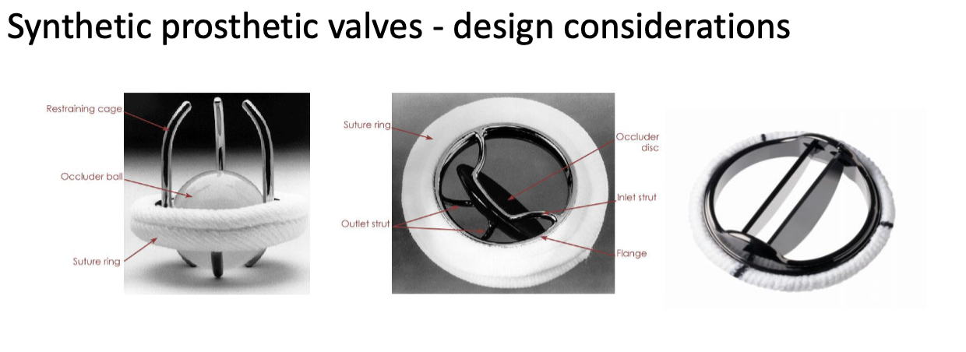

老師上堂課一直在說關於heart valve的那三張圖跟作用機制各自的優缺點哪部分看旋轉之類的，Maybe that is the main point of the lecture 14b? And I think we need to focus on the components, pros, cons, difference of all the heart valve implant, and discuss the solution to avoid the failure.
Note in class:
Biggest concern of the heart valve is the plugging process!
Low density is important for the heart valve. Need this to be stiff and low density.
pyrolytic carbon is common.
For the case study of the 29 years old woman, she must do a surgery for replacement of the heart valve every 15 years to prevent thrombosis.

